NAME:Rishik JK
REG.NO :192511052

CSA1702-ARTIFICIAL INTELLIGENCE
LAB EXPERIMENT

23. Prolog Program to Implement Family Tree

1. Aim
To write a Prolog program to represent a family tree using facts and rules and identify parent, child, and grandparent relationships.

2. Algorithm
- Start the program.
- Define facts for parent relationships.
- Define rules for child and grandparent relationships.
- Give the required query.
- Display the relationship.
- Stop.

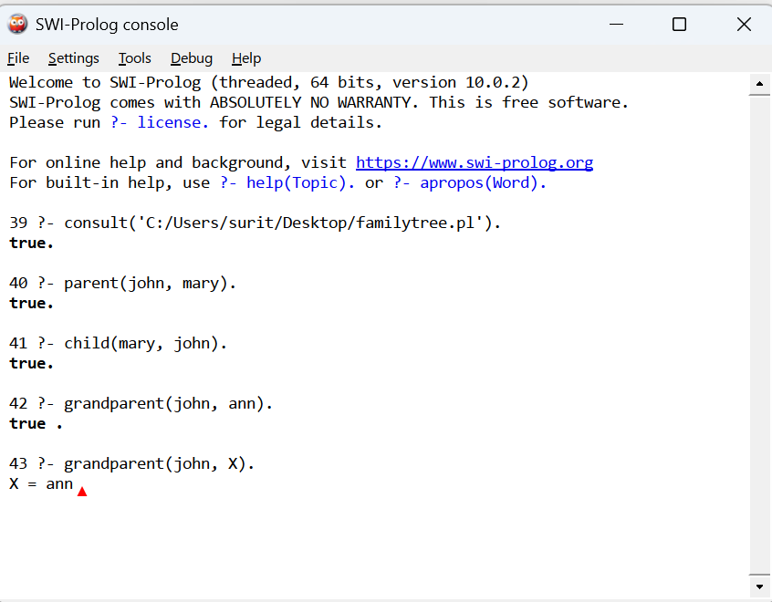

3. Result
Thus, the Prolog program to implement a family tree using facts and rules was successfully implemented and executed. Parent, child, and grandparent relationships were retrieved successfully.

